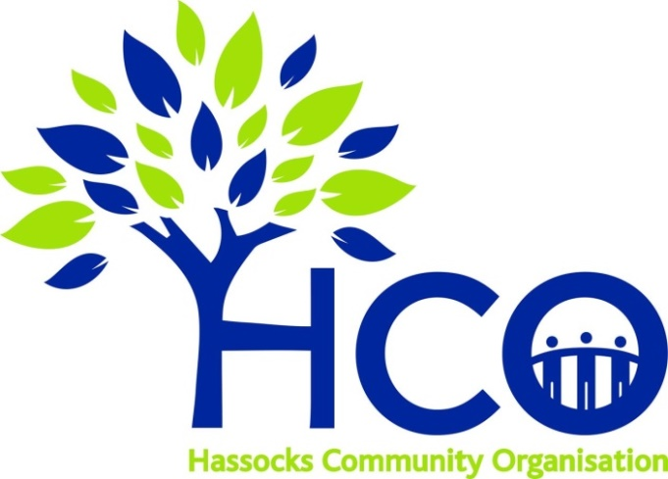

To ensure the laws overseeing our personal data are fit for purpose, European regulators have created a series of new rules. The result is the European General Data Protection Regulation (GDPR), which comes into force on May 25, 2018. It changes how businesses and public sector organisations can handle the information of their customers. Accordingly Hassocks Community Organisation’s GDPR Policy Statement follows:

GDPR PRIVACY POLICY

The security of your personal information is of utmost importance to us. Below we set out the Privacy Policy of Hassocks Community Organisation (HCO), a company limited by guarantee, whose charity registration is currently pending. The registered address is c/o Price Green & Co, Lynnem House, 1 Victoria Way, Burgess Hill, West Sussex, RH15 9NF.
We will treat any information you provide in accordance with this policy and current UK and EU Data Protection legislation.

What information is being collected?
When you agree to become a supporter of HCO we will collect various pieces of personal information, this may include your name, address, email address and telephone number. When you agree to be added to the Volunteer Database we will collect your name and email address and any other relevant information you choose to provide to us. This information may be collected by the Trustees, Treasurer, Supporters Secretary, Volunteer Database Administrator or the HCO Administrators of Hassocks Community Organisation.

How is the information collected?
Your personal data may be collected from the following sources:
- via our website
- via social media including our Facebook and Twitter accounts
- through direct contact from you to our email addresses togetherwithhco@gmail.com and hassocksvolunteers@gmail.com .
- submitted via our marketing leaflets.

How is your information used?
We’d like to keep in touch with you to let you know about the vital work we do in your community and so we may use your personal data in the following ways:
- To send you a copy of our regular newsletter.
- Correspond with you regarding yearly subscriptions and the Hassocks Loyalty Card.
- To contact you regarding official meetings and public fora/engagement opportunities.
- If you have registered with our Volunteers Database we will send you details of local volunteering opportunities.
- To send occasional updates regarding adhoc activities or news which relates to your local community.
We may use your details to contact you directly or through a service such as MailChimp.

Who has access to your information?
The Trustees, Treasurer, Supporters Secretary, Volunteer Database Administrator and the HCO Administrators of Hassocks Community Organisation are the only individuals who will have access to your personal data. We will not share your personal data with third parties unless we have your explicit permission to do so.

How you can access or delete your information.
You are entitled to access or delete your personal data held by us at any time. Please email togetherwithhco@gmail.com or phone the Supporters Secretary on 01273 846481 to make such a request.

Changes to our Privacy Policy.
We will keep our Privacy Policy under regular review and as a result it may be amended from time to time without notice. Whenever we make a change to our Privacy Policy we will place the updated version on our website (www.hassockscommunity.org.uk) with immediate effect. As a result we encourage you to review it on a regular basis.

How to contact us.
If you have any questions in relation to our Privacy Policy please contact us at togetherwithhco@gmail.com. Alternatively you can write to us at:
Hassocks Community Organisation
13 Churchmead
Keymer
BN6 8BN

